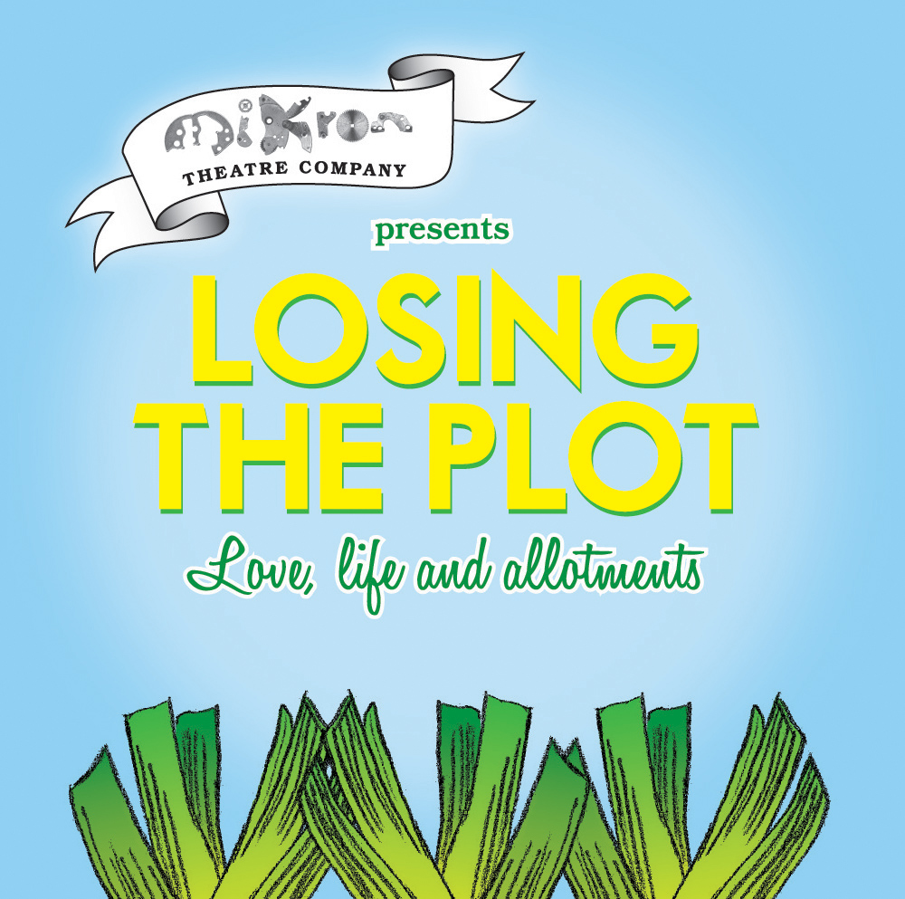

Writer: Deborah McAndrew
Composer: Conrad Nelson
Director: Adam Sunderland
Musical Director: Rebekah Hughes

The gardeners of Thistledale Allotments are a rag-bag bunch of diggers and dreamers. Strong personalities frequently clash over the best treatment for mealy bugs, and the annual ‘Heaviest and Longest’ competition is always a time when old feuds and new flirtations threaten to undermine the fragile peace.

Then Harvey from the Council pays them a visit and they realise that they must pull together, or forfeit their precious plot forever. But can they agree on a strategy? How will they convince Harvey of the vital role allotments have played in the life of the nation for centuries? What will they do when things inevitably get completely out of hand?

Told with a rollicking mix of old music hall tunes and brand new songs, Losing The Plot is a story of love – between people and the land; between people and people; and between people and their giant vegetables.

Artistic Director: Marianne McNamara
General Manager: Peter Toon Honorary Artistic Director: RIchard Povall Founding Artistic Director: Mike Lucas
Patrons: George Monbiot, Lord Montague of Beaulieu, Sonia Rolt, Prunella Scales, Timothy West
Mikron Theatre Company Ltd. Registered in England No. 1055043. Mikron Theatre Company is a registered charity No. 265169
Marsden Mechanics, Peel Street Marsden Huddersfield, HD7 6BW
Tel/Fax: 01484 843701 Email: admin@mikron.org.uk
Website: www.mikron.org.uk

